Your First and Last Name
Bark Beetle Infestation, North America
MWF,
Spring 2018

Bark Beetle Infestation, North America

Synopsis/Summary of the Topic
Warmer temperatures in North America had been promoting the spread of bark beetles in most parts of the region. Recent reports have also indicated that bark beetles are also spreading towards northwards in countries like Canada among other higher elevations. As a result, outbreaks of the bark beetles are killing more host trees such as pine trees than ever. The increased mortality of the trees is promoting global warming as dead trees no longer take carbon dioxide through photosynthesis.
Just recently, NASA reported that bark beetle outbreak is expected to continue for years and to release over a billion tons of carbon dioxide into the atmosphere if global warming is not controlled (Dunn and Crutchfield 2016). This is a ‘negative feedback” loop in which global warming promotes beetle outbreaks that lead to increased destruction of host trees and promotion of global warming.
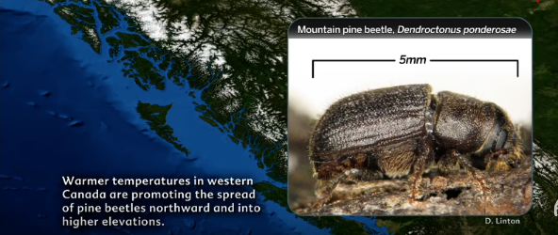
Figure 1: Bark Beetle infestation in North America, Canada
What occurred, where, when?
Bark beetles are native insects that had been having outbreaks for millennia in most parts of North America. There are numerous pictures showing actual bark beetle fragments preserved in sediment records from 8,000 years ago (Canadian Forest Service n.d). The following picture (Figure 2) below shows the thinning opportunity that beetles can create. They also have a preference for larger trees. Once the trees have died, sometimes they allow the growth of the understory as shown on photograph 2 below.
Bark beetles are also host specific targeting the preferred host and, therefore, they should be seen as holistic and as a natural part of the environment. The outbreak affected an enormous amount of land area. The second picture is an example of a photograph that was taken during the mountain pine beetle outbreak from the western side of Canada also known as British Columbia. The infestation began in the late 1990s extended through 2000s until it was controlled in early 2010 (Dunn and Crutchfield 2016). According to Canadian Forest Service, the entire outbreak affected over 10 million hectares of land area.
Why the Outbreak happened?
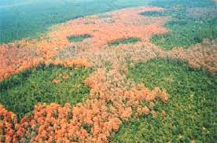
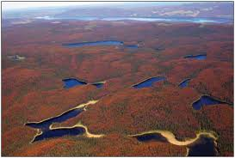
Several sequences of thresholds were crossed that led to the establishment of the outbreak that resulted to the level of the landscape portrayed on photograph 3. Climate change is the number one factor attributed to bark beetle infestations in North America and more specifically in the Canadian Rocky Mountain where infestation has increased exponentially. According to scientists, warmer temperatures in parts of Canada that including the western part of it have been promoting the spread of pine beetles that have been spreading northward and into higher elevations such as in the Canadian Rocky Mountains. In times of drought, beetle populations can spike spreading to healthy pine trees. Historically, cold winters kept beetle populations under control.
Photograph 3: An Annual Area Affected by Bark Beetles in Canada/ Most Recent Outbreak
Photograph 2: Bark Beetle Infestation in parts of North America
There are many ways in which climate influences the disturbance process that results into bark beetle infestation in North America. Disturbances are driven by direct and indirect effects such as climate. Climate has an indirect effect because it influences disturbance through vegetation. Parts of North America such as the western part of Canada had been experiencing warmer climates in recent years. For example, the year 2012 was the warmest year for Canada. The changes in climate that happened in the year were responsible for 57 percent of the disturbances that led to the increased bark beetle infestation in most regions that essentially extended to Canadian Rocky Mountains (Canadian Forest Service n.d). The following map illustrates 2012 mountain pine beetle infestation at Rocky Mountains, Canada.
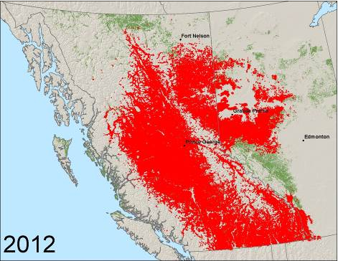
Bark Beetle Infestation in Canada: Map data retrieved from Canadian Forest Service, Mountain pine beetle (factsheet) <http://www.nrcan.gc.ca/forests/fire-insects-disturbances/top-insects/13397>
The effect of warm season or water deficit which is controlled by high temperatures during the warm season is responsible for the infestation of bark beetles in North America. Climate changes from cold season precipitation have also been contributing to large infestation of the bark beetles in most parts of the region.
What is the situation?
Bark beetle outbreaks in the western part of Canada as well as in Northeastern British Columbia and Northwestern Alberta have led to significant distribution of the insects in many parts of the region. For example, certain classes of bark beetles are now spreading at an alarming rate in lodgepole forests in Northern Alberta (Kurz et al. 2008). Mountain pine beetles are also threatening to spread towards east across Canada’s boreal forest if conditions are favorable. Since 2012, the mountain pine beetle has been moving northwards and may invade the region if not controlled (Canadian Forest Service). The following map shows how the insects are spreading northwards in Canada.

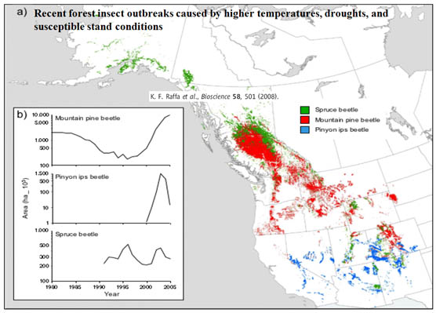
Spread of Bark Beetle Northwards. Retrieved from < http://www.treeandlandscapecompany.com/saving-the-world/impact-of-pine-beetle-spreading-north/>
Who is affected?
The effect of bark beetle infestation in North America can be seen in tree mortality. Increased mortality rate of trees in the region have direct effect on climatic changes which further affect people living in the region. Tree mortality has negative effects in the region as it causes climate deviations which further results into global warming.
What are the effects, ramifications?
As mentioned earlier, the increasing rate of bark beetle infestation in North America has led to increased mortality of target trees such as pine and oak trees. Trees mortality has negative effects as it results into global warming. Destruction of forests can also increase the rate at which bark beetles spread to other areas. This is true because if trees are destroyed, winds are likely to blow the insects eastwards to other areas that were not previously infested (Alberta Sustainable Resource Development 2009). Destruction of forests can also lead to warm temperatures that lead to bark beetle multiplication which means destruction of even more trees. Such effects are ramifications with negative effects of global warming.
Is anyone culpable or responsible?
Human activities are responsible for global warming. For example, deforestation activities have led to warmer temperatures as there are few trees to help in carbon elimination from the atmosphere. People who consistently cut down trees in North America are, therefore, culpable or responsible for the enormous spread of bark beetles in the region.
Who or what is implicated?
Throughout history, climate has been implicated with the infestation of bark beetles in North America. In real sense, human beings are the most risk factors for the enormous infestation of bark beetles in North America. Through deforestation among other activities that promote global warming, human beings had been acting desperately for money without knowing that they had been promoting growth of bark beetles through those activities.
What action is occurring?
To address the issue of bark beetle infestation, various organizations such as the Canadian Forest Service has started initiatives that had been trying to control the spread of bark beetle. Some of the control measures the organization has put in place include suppression of emergent infestations. This involves maximization of extraction of currently infested trees with an intention of minimizing the spread. Such a measure can be viewed as a promising solution even though there are other methods that can be used to prevent infestation. Extraction is a form of deforestation and, therefore, should be the last solution of consideration. Manipulation of the bark beetle is the best method for controlling the spread of the insects. Spays like carbaryl or pyrethroid can be used to kill or eliminate bark beetles without necessarily destroying the trees (Burton 2010).
What is the moral of the story?
Human activities are to blame for the increasing infestation of bark beetles in North America. The moral of the story is that by stopping deforestation activities among other activities that promote global warming, human beings can help control the spread of bark beetles. North American forests that were destroyed by bark beetles can regenerate through adequate stocking of the species that were lost. It is important to note here that this is possible only if global warming is controlled.

Bibliography

Alberta Sustainable Resource Development. 2009. Beetle facts. Edmonton, AB. Online at http://www.mpb.alberta.ca/BeetleFacts.aspx. Accessed April 11, 2018.

Burton, P.J. 2010. Striving for sustainability and resilience in the face of unprecedented change: The case of the mountain pine beetle outbreak in British Columbia. Sustainability (2):2403&nsash;2423, doi:10.3390/su2082403. Online at http://www.mdpi.com/2071-1050/2/8/2403/pdf. Accessed April 11, 2018.

Canadian Forest Service. Mountain pine beetle (factsheet). Available at < http://www.nrcan.gc.ca/forests/fire-insects-disturbances/top-insects/13397> Accessed: 04/11/2018.

Dunn, D. and Crutchfield, J.P., 2016. Insects, Trees, and Climate: The bioacoustic ecology of deforestation and entomogenic climate change. arXiv preprint q-bio/0612019.

Kurz, W.A., et al. 2008. Mountain pine beetle and forest carbon feedback to climate change. Nature 452:987–990, April 24, 2008. doi:10.1038/nature06777. Online at http://www.nature.com/nature/journal/v452/n7190/abs/nature06777.html. Accessed April 11, 2018.

